Step 1 – Enter your email address and password to sign in. You will see the “More information required” prompt.

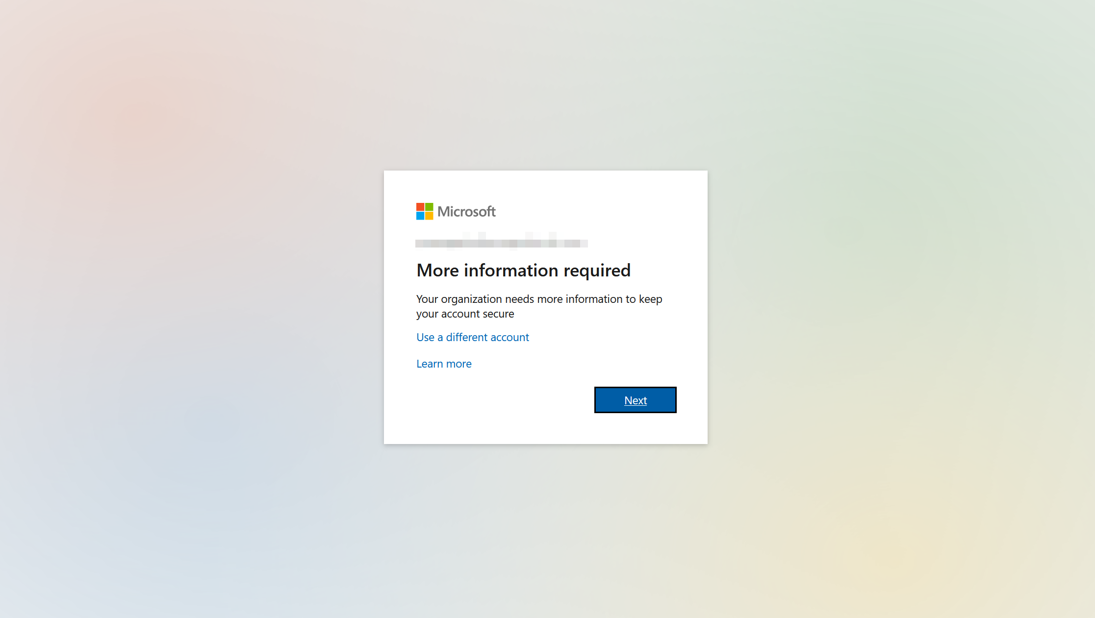

Step 2 – Click “I want to set up a different method”

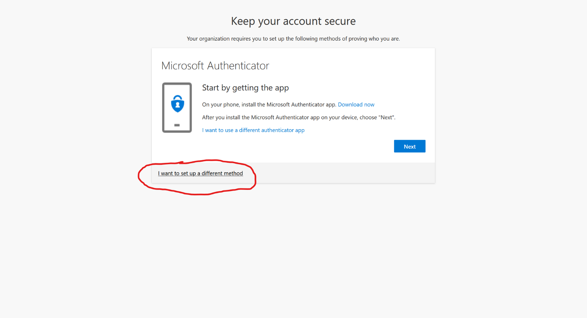

Step 3 – Select “Phone” as the different method.

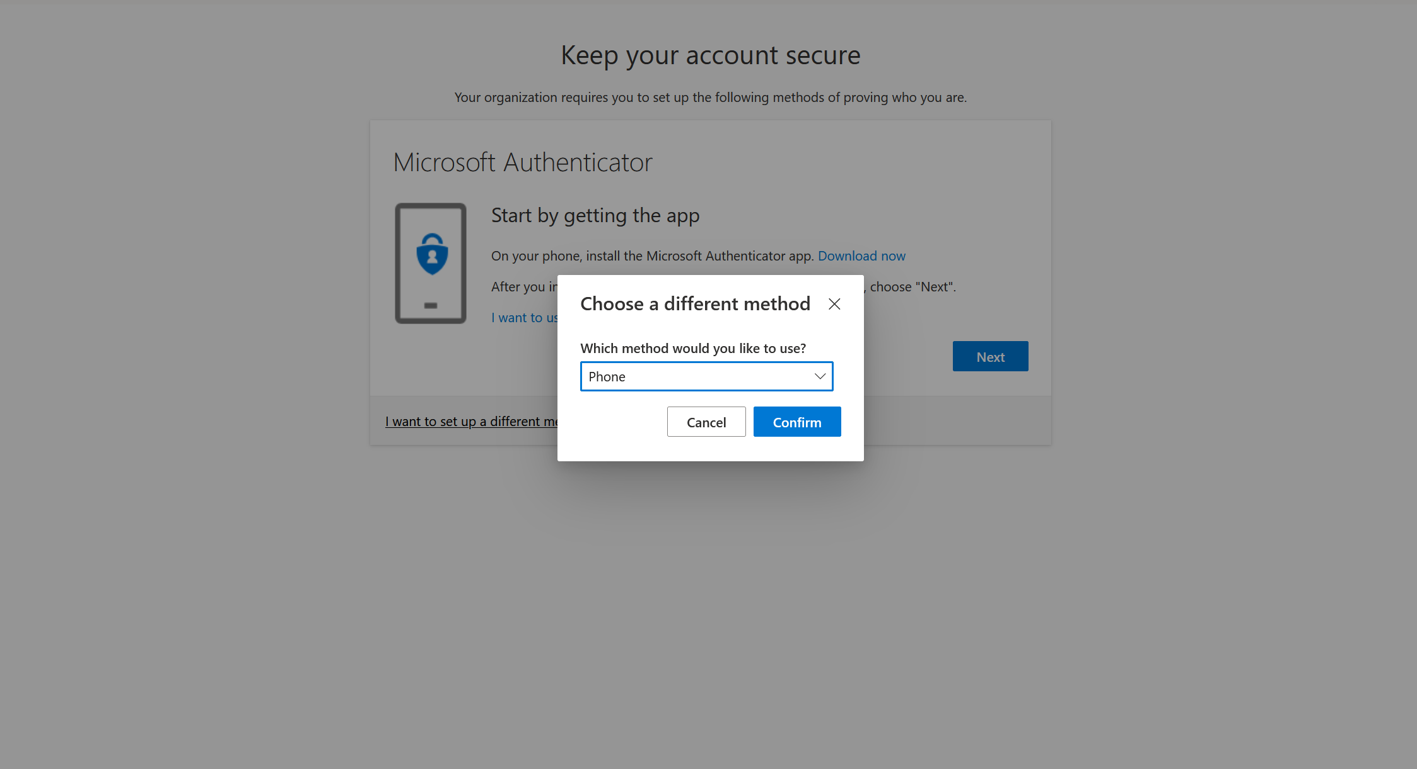

Step 4 – Enter your mobile phone number. Select either “text me” or “call me” and then click next.

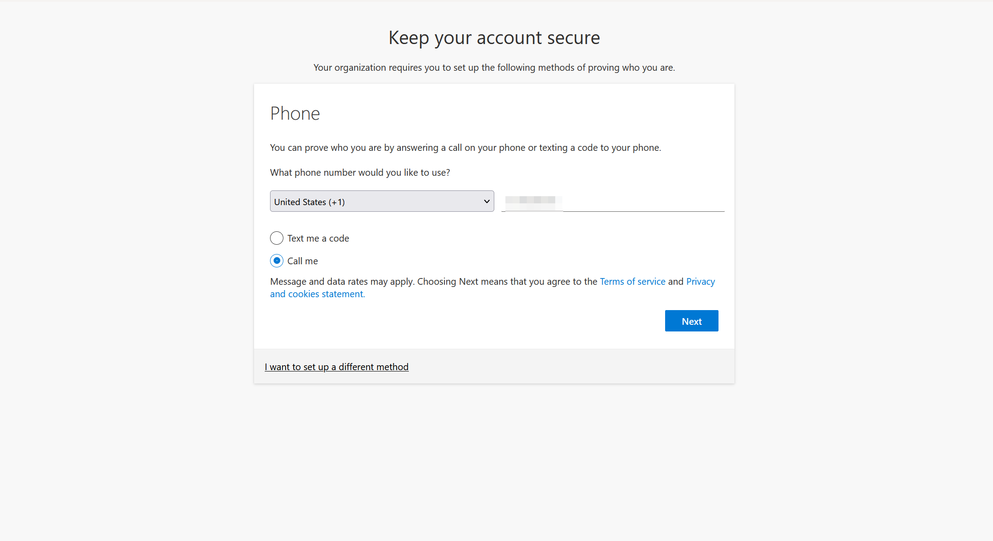

You will receive a text or phone call to complete the verification. That’s it!