Step 1 – Enter your email address and password to sign in. You will see the “More information required” prompt.

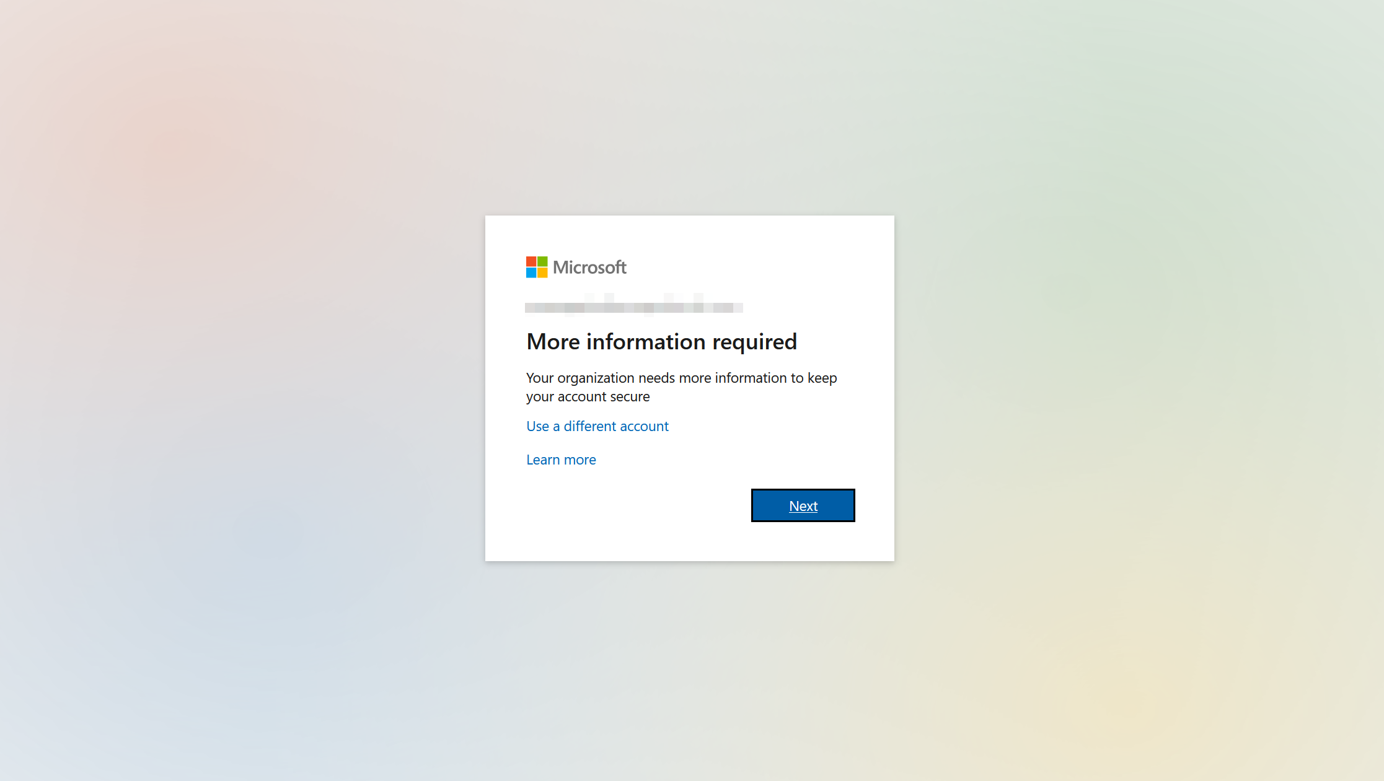

Step 2 – Download the Microsoft Authenticator app to your mobile phone and then click next at the following screen.

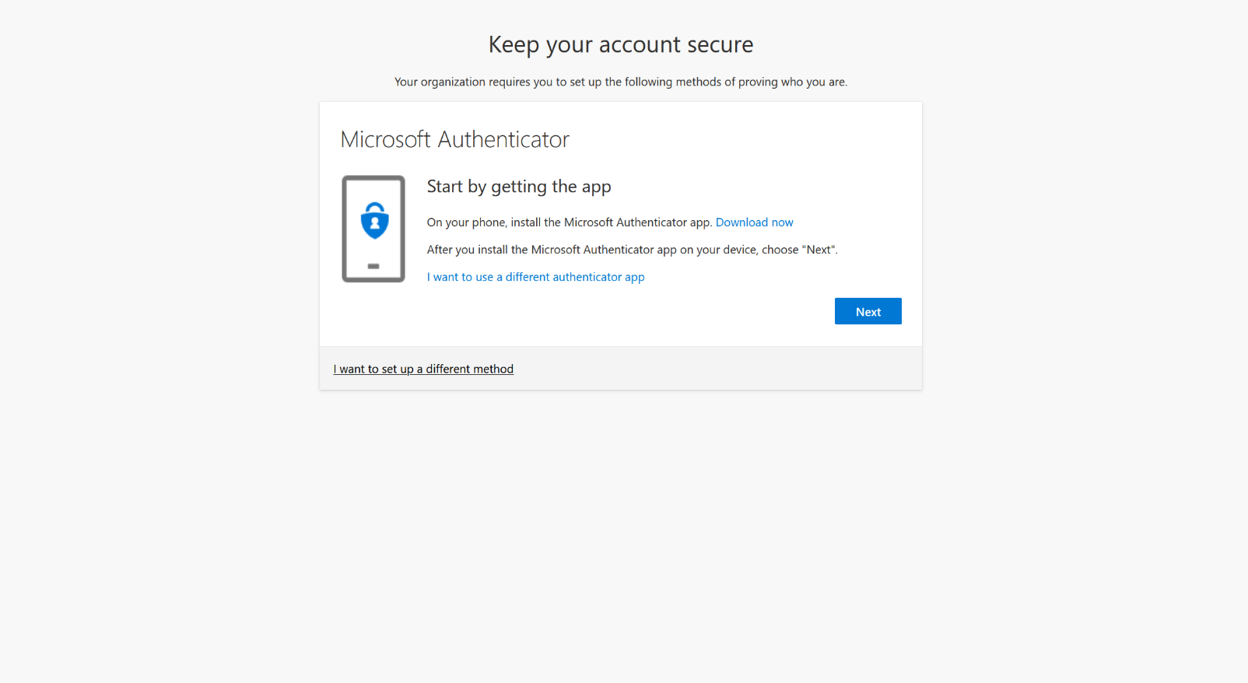

Step 3 – Open the Microsoft Authenticator app on your mobile phone and follow the instructions on the following screen.

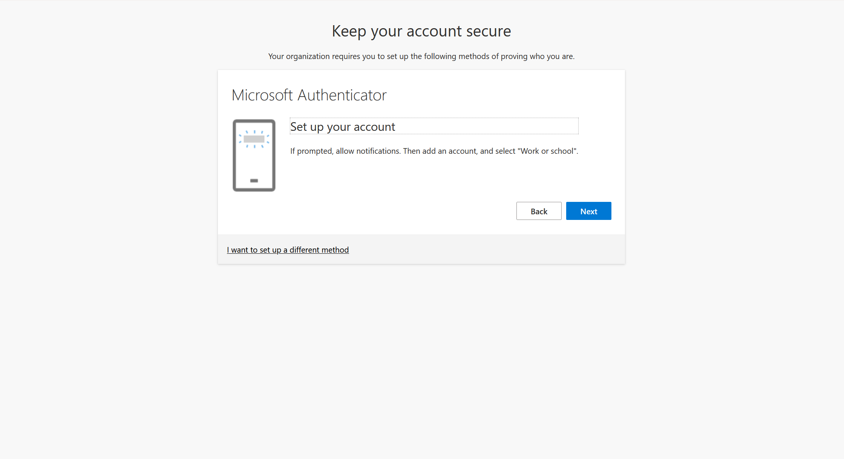

The Microsoft Authenticator app will prompt you to scan the on-screen QR code.

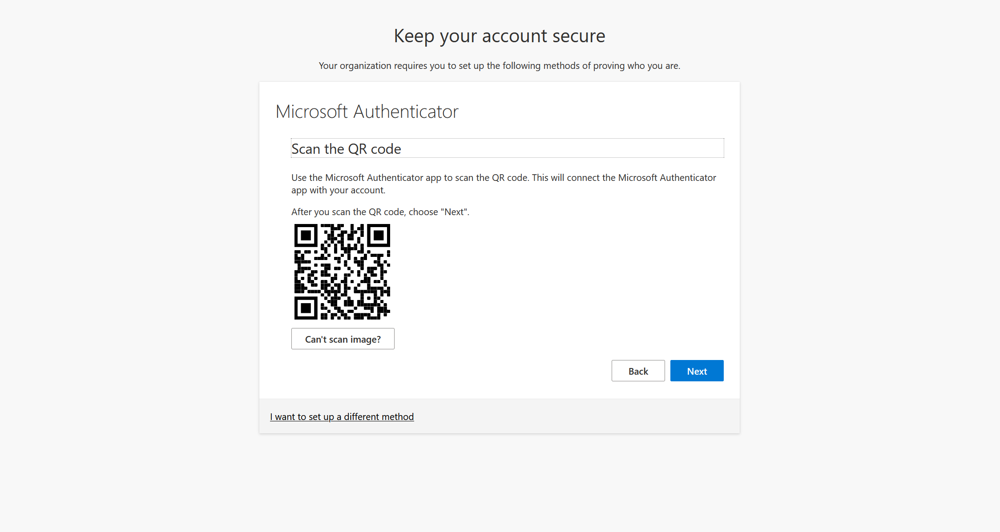

Step 4 – Microsoft will send a test notification to your mobile phone. Tap “Approve” when you see it.

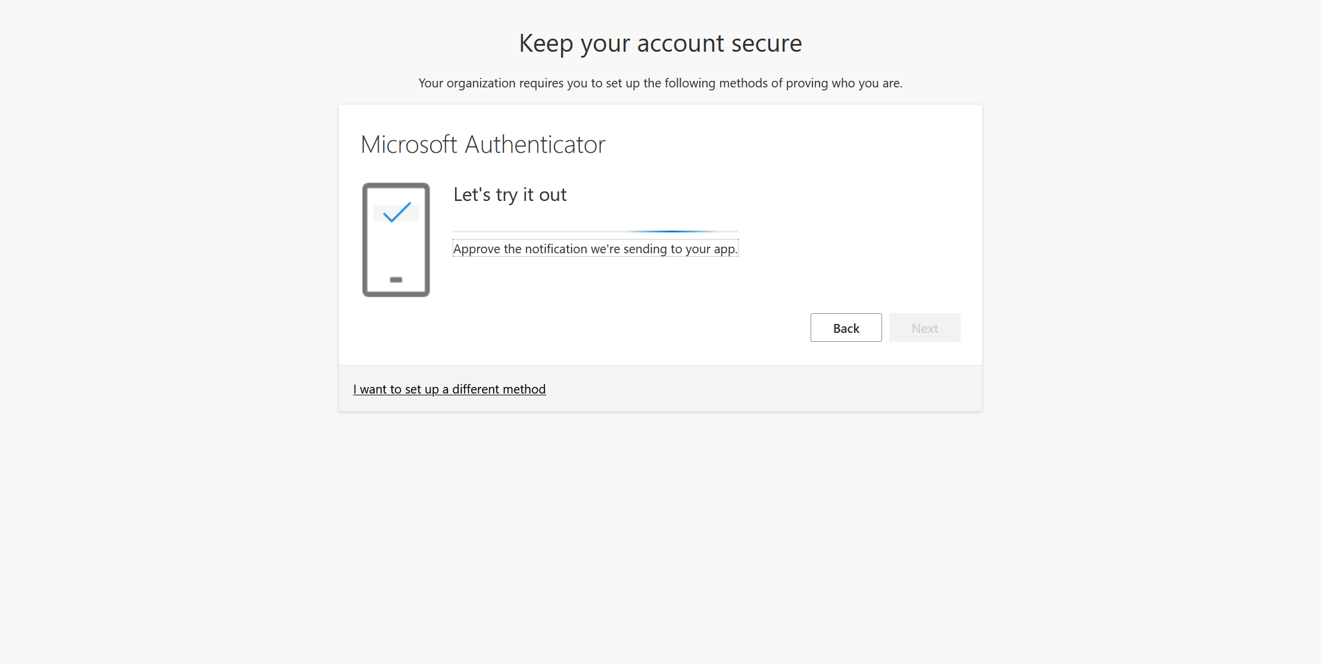

That’s it! If everything was successful, you should see the following screen. Click next and then done.

